Virtual Reality in the Classroom!
**This paper is written in the perspective of thoughts/planning in creating this lesson plan as well as the results and reflections after incorporating the technology during this lesson plan.
Learning has expanded tremendously throughout the history of education. Methods, forms of instruction, and ways to learn have changed throughout time, adapting to current trends and accepted norms. Being the technology age, new forms of multimedia have played a major role in learning, today. Incorporating new technology and multimedia to the classroom is not only a good idea, but also essential for learning. The goal of teaching is also to make your lessons engaging for the class. If students are not engaged, they pay attention less, retain less information, and have a decrease in motivation to pay attention, participate, and succeed in this environment. Personally, the coolest and most intriguing modern technology is virtual reality (VR). Virtual reality allows the user to visualize themselves in a new setting, feeling as if they are experiencing whatever they are viewing (full 360 degrees) through the virtual reality. Typically, some form of goggles or headset is used as the hardware to transmit the virtual reality. I believe that Social Studies is the perfect subject to implement virtual reality due to the various components that can be viewed with this technology, such as battlefields, geographic locations (from various time periods), and much more.
I am not going to be utilizing virtual reality for another two weeks once one of the teachers goes on a temporary leave. However, during this time (before she leaves) we have discussed my virtual reality idea and even decided to perform a mock trial with this technology during this week to introduce this new tool to the students. My plan (for both sessions) is to use the VR as one segment in a group station activity, so that it’s just an introduction to this tool as well as no added pressure to master this technology. ClassVR is an amazing site that provides subject and topic programs to use as VR for the classroom. Augmented reality is also an option of use within this site as well. Dominic Broad, a sixth grade teacher from Barry Island Primary School in Wales, proclaimed, “Over the past few months we’ve been experimenting with some new and creative methods to engage our children within the classroom. Through using our recently acquired ClassVR headsets, we’ve found a vast improvement not only in children’s engagement with learning, but in their motivation to both plan and write a story.”
I’m going to be testing out this technology with a sixth grade Social Studies classroom. The students have been in the middle of their Ancient Egypt unit, currently. Students have learned about pharaohs, such as Ramses II, Tutankhamen, Hatshepsut, features, such as The Great Pyramids of Giza and The Sphinx, and cultural attributes, such as hieroglyphics, new architecture, and body embalming/afterlife. The activity involving this virtual reality will be viewed as a review/summation activity for the unit. During this activity, students will be viewing both the Great Pyramids of Giza and an Ancient Egyptian coffin. There will be four VR headsets available that students will use in groups. Students will be in groups of four viewing four different stations (sixteen student class size). Two stations will consist of viewing those two VR experiences, while the other two stations consist of a short reading and image(s). Each VR station will have two pairs of goggles, totaling four sets. An accompanying worksheet has students answering 2-3 questions per station relating to observations, drawing conclusions, and making connections between previous content learned to new things observed during the stations. The two VR stations have students meeting standard two of world history and standard three of geography for the NYS framework. In the anchor standards (Integration of Knowledge and Ideas), students will integrate and evaluate content presented in diverse formats and medias, including visually and quantitatively, as well as in words (standard 7) and analyze how two or more texts address similar themes or topics to build knowledge or to compare the approaches the authors take (standard 9). The students will use this new technology to aid them in completing their handout, which will be used as one of their study guides for their unit exam. This technology is used to enhance the learning process, not replace it.
I’m very familiar with this sixth grade class, so when I pre-made the groups for this station activity, I carefully ensured that groups were composed of students with varying abilities. Students with high reading levels were paired with students with lower reading abilities. Students, who I’ve noticed have been more creative in class were grouped with more technical thinkers. Students with I.E.P.s also received a modified version of the class worksheet, which simplified the wording in questions as well as contained bolded/underlined words that were key or important to the question. In previous activities, I’ve noticed that these modified worksheets really aid in student learning because there are less distractions on the page for the student and the bolded sections help the student narrow down their train of thought of where/what to focus on. For this particular assignment, which consists of timed slots at each station, it is important to ensure students are focused on the task at hand with as few as distractions as possible for them.
A fly on the wall would view this lesson plan as so: once students are settled in their seats, our Bellringer consists of a K.W.L. chart. A K.W.L. chart takes a topic and separates it into three categories: What I know, what I want to know, what I’ve learned. Since students have been spending the past two weeks on Ancient Egypt, students already know a good amount of information on the topic. After three minutes of writing responses and two minutes of sharing responses, students will be instructed on the gallery walk that they’ll be participating in the day. Groups will be posted on the front board as I distribute the accompanying worksheet for the activity. The four stations include a short reading a social class pyramid, the virtual headset viewing the Great Pyramids of Giza, a map of Ancient Egypt including geographic features, and finally the virtual headset viewing an Ancient Egyptian coffin. There are four total headsets, so two will be placed at each virtual station with the four students taking turns to view the images provided. Students will be given about 7-8 minutes per station, with a digital timer on the Smartboard to remind students how much time is remaining per station. Students will be constantly reminded to complete the questions on their worksheet and if they learn anything new or interesting to also add to their K.W.L. chart. As students rotate from station-to-station, I’ll be browsing around the classroom, but focusing more at the virtual reality stations to aid in any technological questions or issues, since this is the first time these students are using this form of technology to learn. The questions provided for each station consist of an observation question, an inference question, and/or drawing conclusion(s) question. The ending of the class will consist of students finishing their ‘L’ column and a brief class discussion about the content, but also their thoughts on using this new technology and if/how it aided learning.
The questions’ worksheet will be collected at the end of the period and be graded as a quiz grade. After I view the worksheets and if I notice difficulty relating to the usage of technology as a source, then I’ll grade the assessment as a classwork. I will make this decision as I notice student behaviors during and after the lesson. An additional class participation grade (Scale of ten points) will be added to this grade, which will consist of how well students worked in a group together and their participation in the group activities and review. The goal of this activity is to allow students to be exposed to a new form of technology that (most) they haven’t experienced before. By introducing virtual reality in the classroom in low-pressure environment, students will feel more comfortable when using in the future. As stated prior, I do not want students to feel overwhelmed when using the virtual reality, so by introducing it in a relaxed environment and by not including it as a major grade, students will not feel added pressure to use the virtual reality perfectly and enjoy the experience.
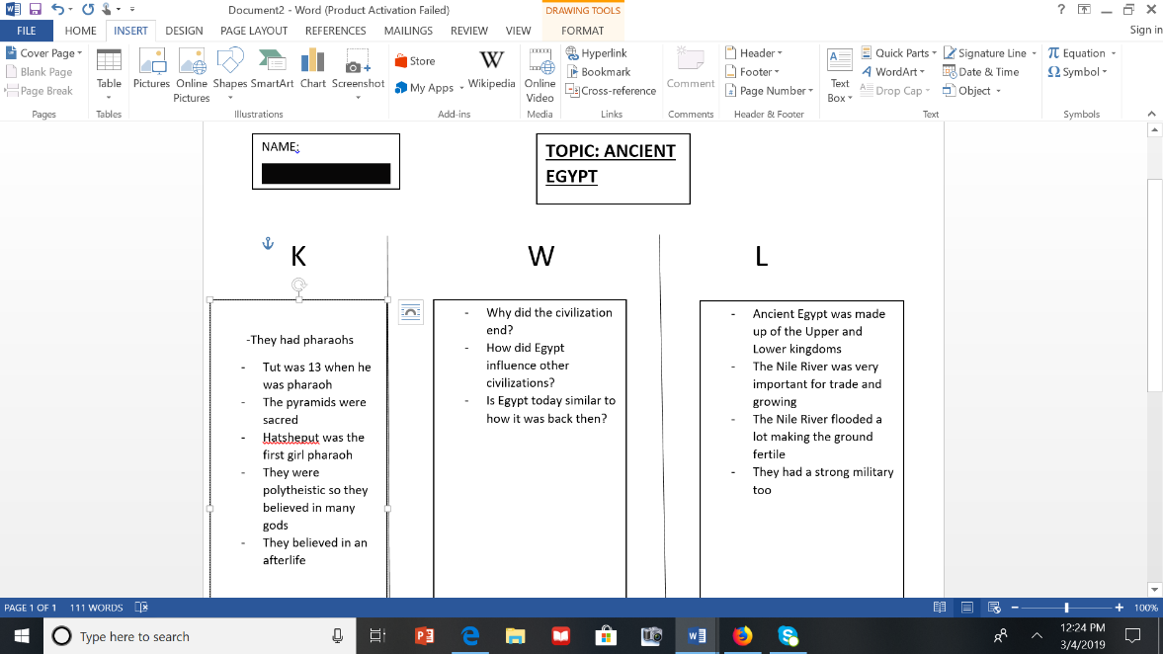
After completing the lesson and reflecting with the primary teacher in this classroom, we came to the conclusion that virtual reality is a great, new tool to be introduced into the classroom. Students were very excited when I mentioned the idea of using virtual reality. Students shared experiences of their own personal encounters with virtual reality. One student attended the VR World in New York City, which I also attended last summer and shared similar experiences. The lesson itself followed the time constraints that I set aside for each activity (K.W.L. chart, formation of groups, participating in the gallery walk, completing their handouts, finishing their K.W.L. charts, and participating in a class discussion about what was learned today). There were aspects of the lesson that went extremely well, but there were also components that could be strengthened for when I incorporate this technology with the eighth graders involving WWII in a few weeks. Group size (4 students) were appropriate in allowing students enough time to take turns with the virtual reality equipment. Each student spent about two minutes viewing the virtual reality content (per station). Reactions while the goggles were on the students consisted of oohs, aahs, laughter, and curious thoughts. One of the most popular questions asked during this activity was if that was what Ancient Egypt actually looked like. They were amazed that they were able to view accurate representations of regions on the other side of the world from thousands of years ago. One issue during the activity was when groups were at the two non-virtual reality stations, it was noticeable how eager they were to speed through their station and get ready for the virtual reality station(s). I feel as if not enough thought and effort was put into the other two stations from the students. If virtual reality was used on a more (semi) regular basis in the classroom, I feel as if it would be easier to hone students in and keep them on track. There wouldn’t be that initial shock and excitement levels to use this technology as there was during this lesson. Also, it was a difficulty (at first) having students take turns with the technology. There were two goggle headsets at each station, so two students would view the information while the other two would patiently wait. In the future, the students who have the goggles on I’d have them verbally describe what they are viewing so that the other students who aren’t currently viewing can either take notes or have some sort of role, rather just standing there. But the introduction of this technology did prove to be successful. During the class discussion, students were making connections from previous material learned with what they viewed during the gallery walk. The primary teacher in the classroom told me she never used this type of technology in her classroom before and was pleased with the results. She wants to utilize virtual reality again in the future.
Pictured left is a copy of a student’s K.W.L. chart on Ancient Egypt. Their name has been blanked out to protect their identity.

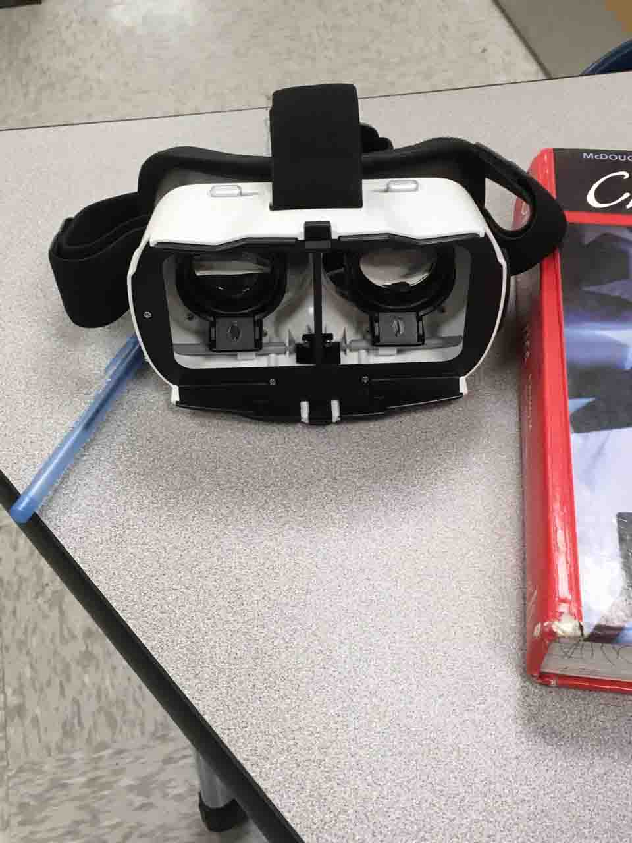
Due to school policy not allowing me to take a picture of a student using the VR headset, pictured right is the hardware that the students used to complete their gallery walk.

